

Infosys Internship Program

Project: debate-verse

Mohit Singh | msakra000@gmail.com | 12/31/2024

**DebateVerse**

**Introduction**

**Objective**: DebateVerse is a web-based platform that allows users to engage in structured debates on various topics, fostering critical thinking and discussion.

**Features**

* User Authentication (Sign-Up, Login, and Role-Based Access Control)
* Create and Join Debate
* Real-Time Voting
* Filtering Debates and Users
* Manage Users and Debates
* Analytics for Debates (e.g., participant statistics, voting outcomes)

**Technology Stack**

**Frontend:**

* **Framework**: Angular
* **Libraries**:
  + Angular Material (for UI components)
  + ngx-toastr (for notifications)
  + ngx-pagination (for paginated views)

**Backend:**

* **Framework**: Spring Boot
* **Libraries**:
  + Spring Security (for authentication and authorization)
  + Spring Data JPA (for database interaction)
  + Hibernate Validator (for data validation)

**Database:**

* MySQL

**Tools:**

* Postman (for API testing)
* GitHub (for version control)

**Architecture Diagram**

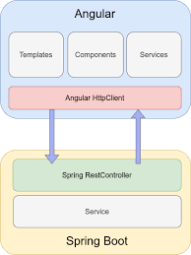

**API Endpoints**

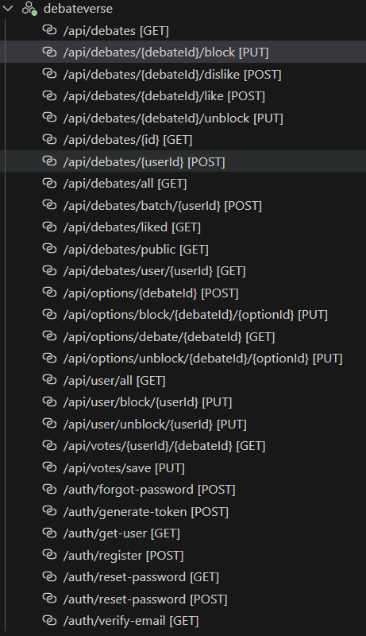

**Screenshots**

(Include clear screenshots of the following pages with captions):

1. **Debate Creation Page**

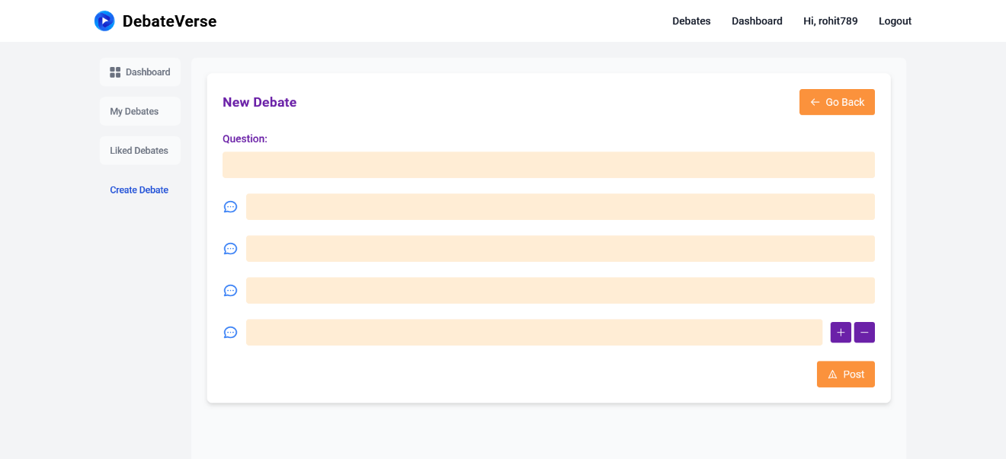

1. **Debate Room Page**

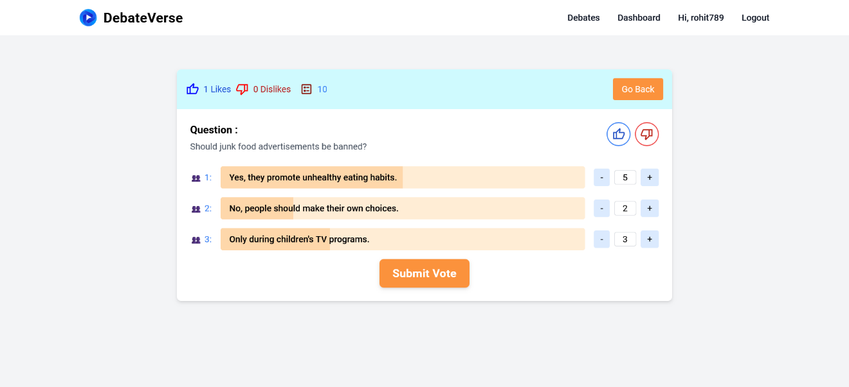

1. **User Debates**

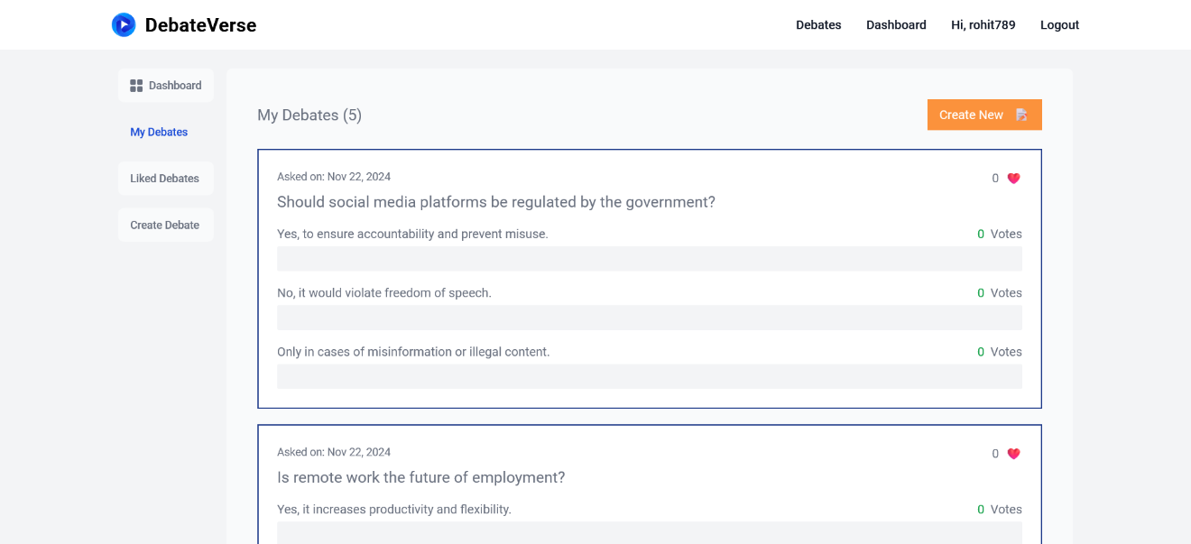

1. Debates

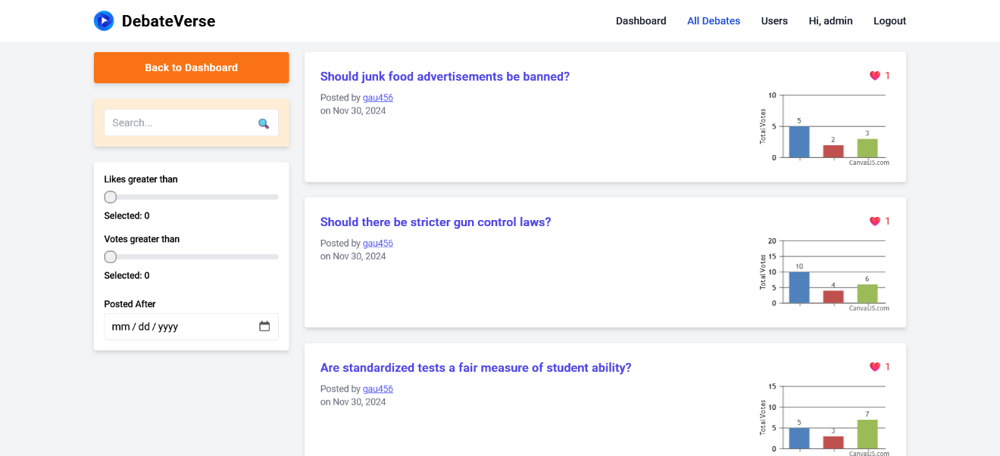

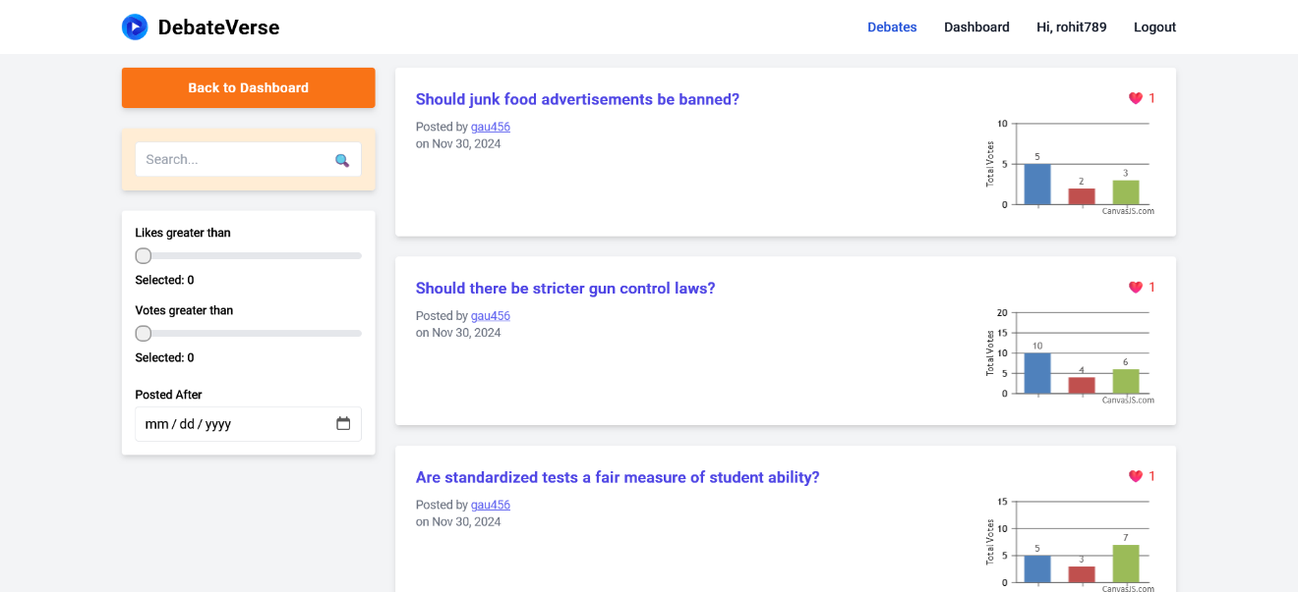

1. Users

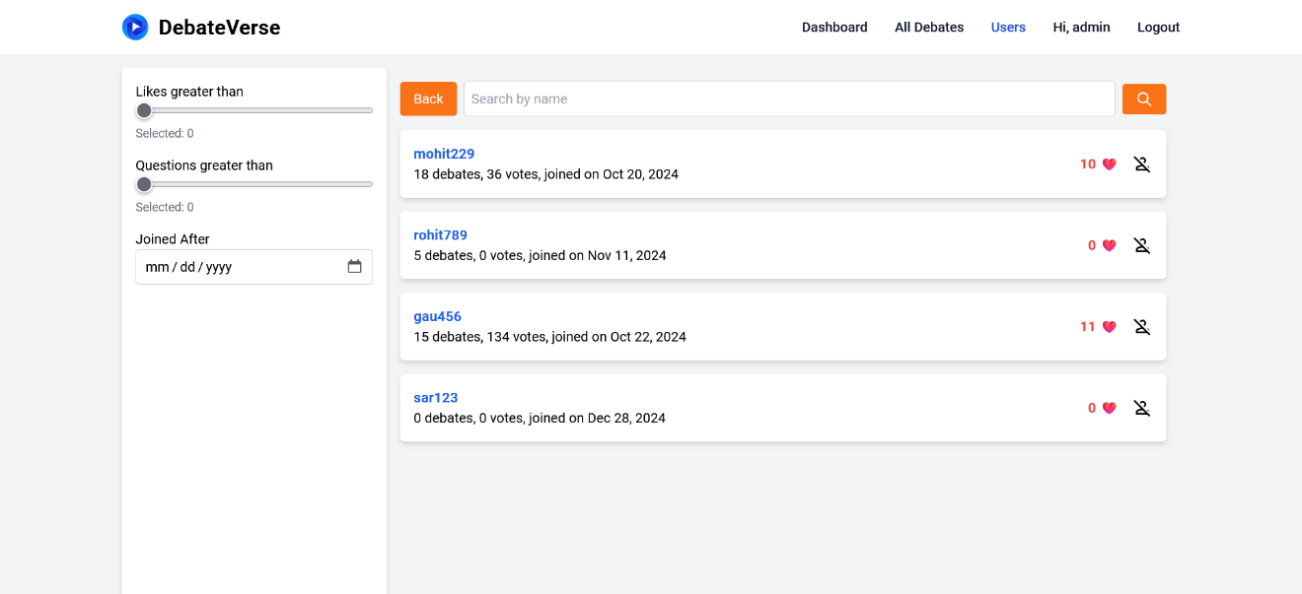

**Future Scope**

* Mobile App Integration
* Real Time Updates
* Advanced Analytics (e.g., sentiment analysis for debates)
* Multi-language Support

**Conclusion**

DebateVerse serves as a robust platform for encouraging intellectual discussions and enhancing public speaking skills. It combines powerful technologies to deliver a seamless and interactive user experience.